Andrew Sommer

12/18/17

DAND

Term 1 – Project 1: Explore Weather Trends

Data was extracted from the provided databases using two SQL queries. The Atom text editor was used to organize the code and highlight keywords in the syntax.



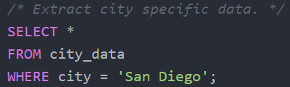

Tabular results from these two SQL queries were exported as .csv files for post-processing in Excel. To smooth the data a 12-year moving average was calculated using the AVERAGE() function.

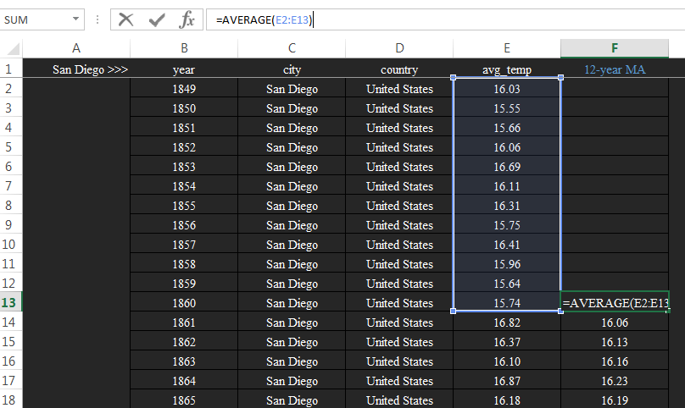

Several observations are made from a line plot of the 12-year moving averages for San Diego and global temperatures.

1. San Diego is consistently hotter than the global average by around 8 [°C]. This implies that San Diego is exposed to more sunlight than majority of the earth’s surface.

2. San Diego experienced a 15 year decline in temperature around 1940 while the global temperature remained nearly constant. This implies that the global climate is not uniform with some areas of the earth’s surface decreasing in temperature while others increase.

3. San Diego data prior to 1849 does not exist; global data prior to 1849 is much more variable than the global data post 1849. This variability may be reason to suspect methods of data collection prior to 1849.

4. The clear trend of both San Diego and global temperature since 1900 is a steady increase with the most dramatic rise beginning in 1980.

